Type cmd under search and click on Command Prompt
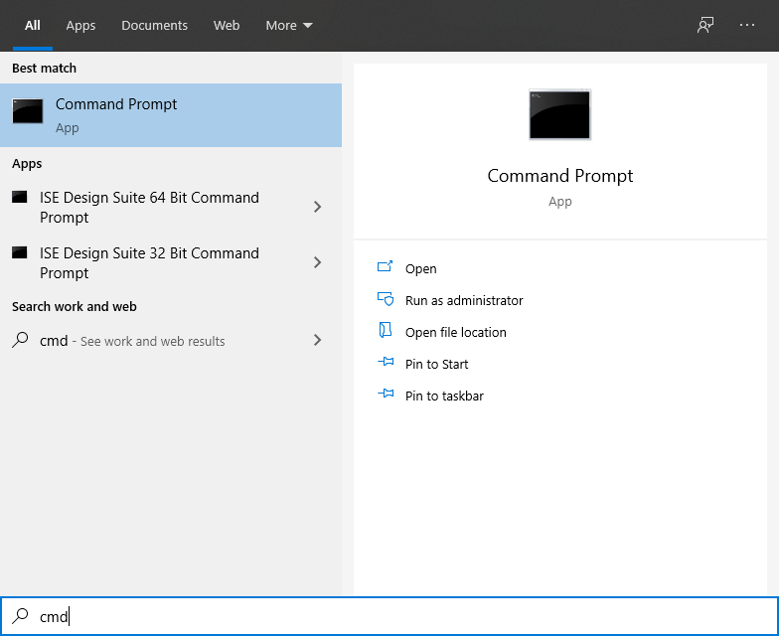

Goto the directory with program : cd c:\XXXX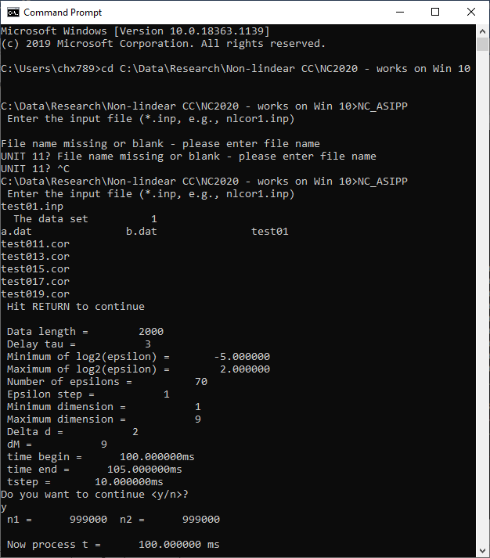
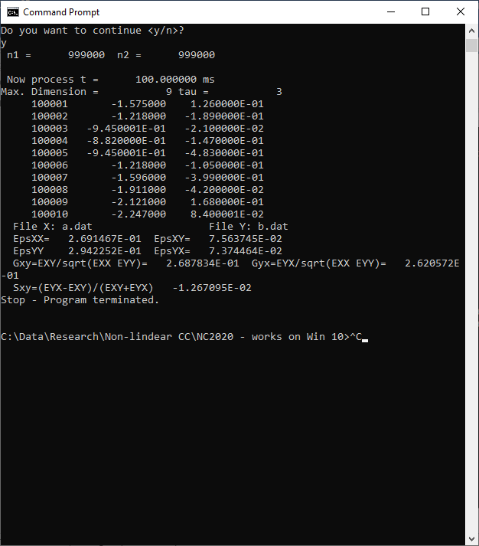

July 18, 2022:
Vineet’s Matlab version in
Reactor:\Vineet_NLCC\CX_Vineet_NLCC_HT7_data_19_July, 2022
%% modified and made it work by Vineet (Mitacs summer sturdent) May-July, 2022
%% tested by C. Xiao for the input file test_cx_dat
%% and compared with the run NC_ASIPP.EXE (under command prompt) for the input file test_cx.par
%% added ployting and saving parts to the original program
%% Nonliner cross correlation coefficients are saved in the file: test_cx.par
%% plotting data are saved in the following files: test_cx1.dat, test_cxi.dat, ... test_cx9.dat

Results for dimension =9 renders the exact result as the run for NC_ASIPP.EXE
